SIGNATURE PAGE
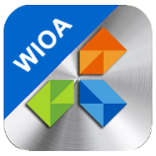
This plan represents the best efforts of CareerSource Brevard to maximize the resources available under the various funding sources establishing the One-Stop/Career Center System in Brevard County for the Local Workforce Development Board 13. The plan was electronically submitted on or before March 16, 2020 and meets the requirements specified by the state which includes: Local Board Approval & Chief Elected Official. The plan covers the period of July 1, 2020 through June 30, 20224 and has been updated in accordance with the instructions provided by the CareerSource Florida (CSF). The plan contains local information and data necessary to provide the vision, goals, objectives and strategies necessary to ensure that Brevard County contributes to Florida becoming a “top performing economy and be recognized as the world’s best place to live, learn, work, and do business”. This plan represents the efforts of CareerSource Brevard to implement the Workforce Innovation and Opportunity Act in Brevard County, Florida. CareerSource Brevard will operate in accordance with this plan and applicable federal and state laws, rules, and regulations.

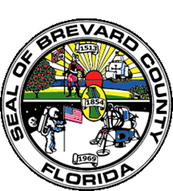
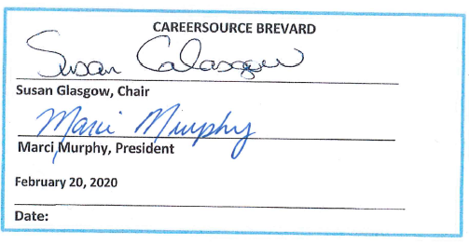
CHIEF ELECTED OFFICIAL (CEO)
Brevard County Board of County Commissioners

______________________________________________________________________
Bryan Lober, Chair

Attest: _______________________________________________________________
Scott Ellis, Clerk

______________________________________________________________________
Date: (As Approved by the Board on 04/21/2020)

