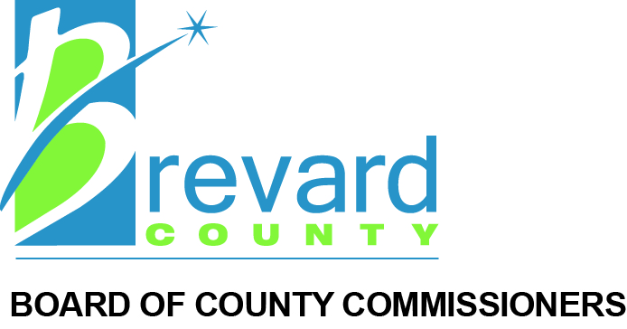

Business Impact Estimate
This form must be uploaded into Granicus to be included in the agenda packet for the item under which the proposed ordinance is to be considered, and must be posted on the County’s website by the time notice of the proposed ordinance is published.

Proposed ordinance’s title/reference:
Amendment to Chapter 62, Article X, Division 6, Section 62-3751, Exhibit A - Stormwater Management Criteria; Subsections 4.6(d) and 4.6(j), Brevard County Code of Ordinances, to allow polypropylene pipe in the County right of way and provide for administrative waivers for inverted siphons.

Pursuant to Section 125.66, Florida Statutes, a business impact estimate is not required if any of the following statements apply. Check all that apply and include this page in the agenda packet for the proposed ordinance under consideration.
☐ The proposed ordinance is required for compliance with Federal or State law or regulation;
☐ The proposed ordinance relates to the issuance or refinancing of debt;
☐ The proposed ordinance relates to the adoption of budgets or budget amendments, including revenue sources necessary to fund the budget;
☐ The proposed ordinance is required to implement a contract or an agreement, including, but not limited to, any Federal, State, local, or private grant, or other financial assistance accepted by the
☐ The proposed ordinance is an emergency ordinance;
☐ The ordinance relates to procurement; or
☒ The proposed ordinance is enacted to implement the following:
a. Part II of Chapter 163, Florida Statutes, relating to growth policy, county and municipal planning, and land development regulation, including zoning, development orders, development agreements and development permits;
b. Sections 190.005 and 190.046, Florida Statutes, regarding community development districts;
c. Section 553.73, Florida Statutes, relating to the Florida Building Code; or
d. Section 633.202, Florida Statutes, relating to the Florida Fire Prevention Code.

In accordance with the provisions of Section 125.66, Florida Statutes, and in the absence of an exemption listed above, the County hereby publishes the following information:

1. Summary of the proposed ordinance (must include statement of the public purpose, such as serving the public health, safety, morals, and welfare):
The proposed amendments serve the public health, safety, and welfare of the citizens of Brevard County, while also allowing development projects to become more efficient.

2. Estimate of direct economic impact of the proposed ordinance on private, for-profit businesses in the County:

☐ No direct economic impact is expected.

Estimated impact:
Economic impact is indeterminable, however, additional flexibility in for site specific design and material options are expected to provide incremental cost savings to the development community.

3. Estimate of direct compliance costs that businesses may reasonably incur if enacted:

☒ No direct compliance costs for businesses are reasonably expected.

Estimated compliance costs:

4. Any new charge or fee imposed on businesses subject to the proposed ordinance, or for which businesses will be financially responsible:

☒ No new charges or fees will be imposed by the proposed ordinance.

New charges or fees imposed:

5. Estimate of the County’s regulatory costs, including estimated revenues from any new charges or fees that will be imposed on businesses to cover such costs:

☒ No increase in County regulatory costs is expected.

Estimated regulatory costs:Inspection and review methods will vary with design and product changes, however, it is not anticipated that additional resources will be needed.

6. Good faith estimate of the number of businesses likely to be impacted by the proposed ordinance:
These changes are anticipated to impact all businesses permitting and constructing new development within Brevard County.

7. Additional information that the Board of County Commissioners determines useful:

In 2014, polypropylene pipe (PPP) passed the needed testing to be accepted for 100-year side drain, cross drain and storm sewer applications for use by the Florida Department of Transportation. PPP is used widely across municipalities in the State of Florida. It is far superior to other plastic pipe material options. Staff have reviewed the current material requirements and observed how these pipes have performed since 2014. Staff reached out to FDOT and other municipalities to obtain feedback on maintenance performance and conducted site visits during installation.
Staff also reached out to the development community to discuss the challenges with inverted siphons and develop criteria that would allow these systems to be maintained in a manner that would allow them to successfully function.

