RESOLUTION 2023-_______
A RESOLUTION AMENDING THE ENVIRONMENTALLY
ENDANGERED LAND PROGRAM'S LAND ACQUISITION
MANUAL MEMBERSHIP ON THE SELECTION AND
MANAGEMENT COMMITTEE AND WAIVING THE LAND
ACQUISITION MANUAL REQUIREMENT FOR REVIEW OF
CHANGES TO THE MANUAL BY THE EEL PROCEDURES
AND SELECTION AND MANAGEMENT COMMITTEES.

BE IT RESOLVED BY THE BOARD OF COUNTY COMMISSIONERS OF BREVARD COUNTY, FLORIDA:
WHEREAS, the Board of County Commissioners adopted the Land Acquisition Manual for the Environmentally Endangered Land Program by resolution, and
WHEREAS, the Board of County Commissioners is required to appoint Environmentally Endangered Land Program Selection and Management Committee members periodically, and
WHEREAS, the Board of County Commissioners has determined there is a need to add two additional voting seats to the EEL Selection and Management Committee for individuals with a background and expertise in either business, finance or real estate, and
WHEREAS, the Land Acquisition Manual of the Environmentally Endangered Land Program currently requires review of all changes to the Land Acquisition Manual to be reviewed by the Environmentally Endangered Land Program Procedures and Selection and Management Committees, and subsequently by the Board of County Commissioners, and
WHEREAS, the Board of County Commissioners wishes to amend the committee membership absent review by the committees described above, and
WHEREAS, because the Board of County Commissioners adopted the Land Acquisition Manual for the Environmentally Endangered Land Program by resolution, it may amend and/or waive the Land Acquisition Manual by resolution.

NOW, THEREFORE, BE IT RESOLVED BY THE BOARD OF COUNTY COMMISSIONERS OF BREVARD COUNTY, FLORIDA:
SECTION 1: The Amendment and Updating Procedures on page 10 of the Land Acquisition Manual are hereby waived for purposes of this Resolution and the

alteration of the Environmentally Endangered Land Program Committee membership composition.
SECTION 2: Pages 7, 12, 14, 19, 21, 23, 34, 36, 39, 40, 51, and 110 of the Land Acquisition Manual related to the composition of the Selection and Management Committee are hereby amended to add additional members. The revised pages are attached as “Exhibits A thru L”.

DONE AND ADOPTED in Regular Session of the Board of County Commissioners of Brevard County, Florida, on this __ day of _____ , 2023.

By: Brevard County Board of County Commissioners
________________________________________
Rita Pritchett, Chair
(as approved by the Board on _____ , 2023)

EXHIBIT A
Land Acquisition Manual page 7
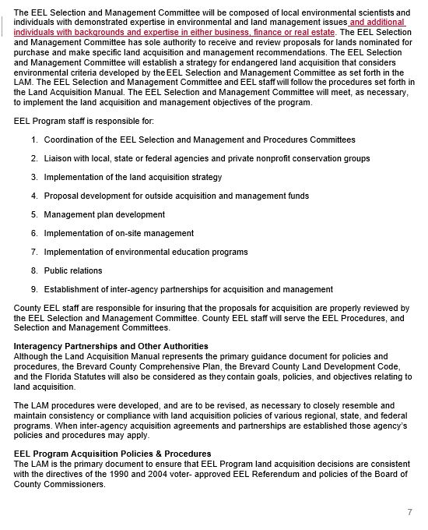

EXHIBIT B
Land Acquisition Manual page 12

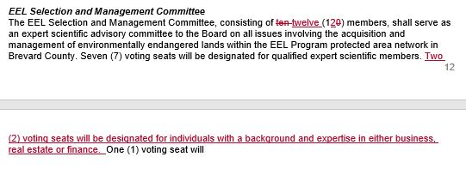

EXHIBIT C
Land Acquisition Manual page 14
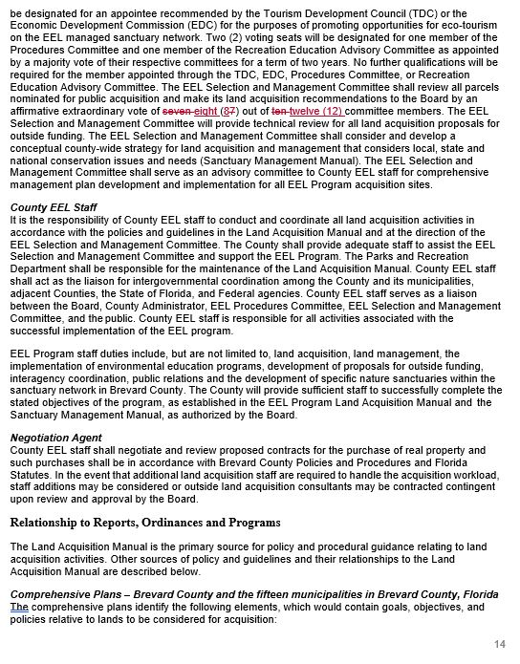

EXHIBIT D
Land Acquisition Manual page 19

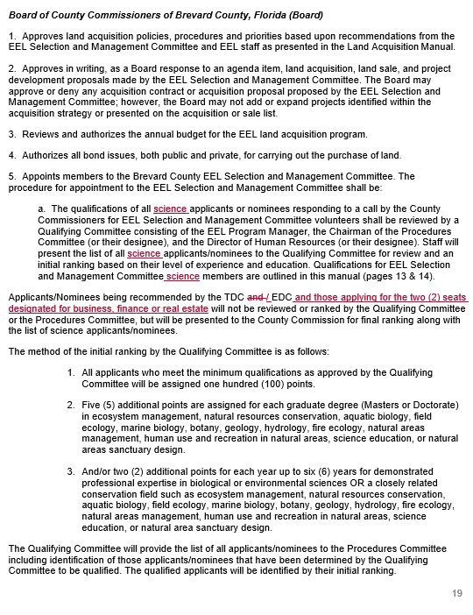

EXHIBIT E
Land Acquisition Manual page 21

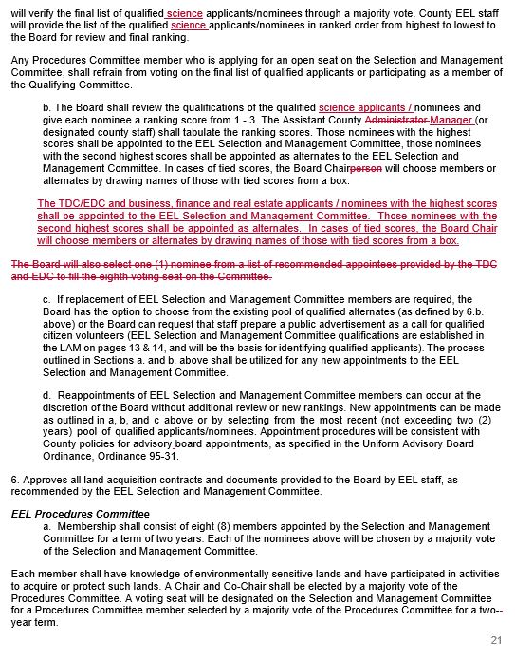

EXHIBIT F
Land Acquisition Manual page 23

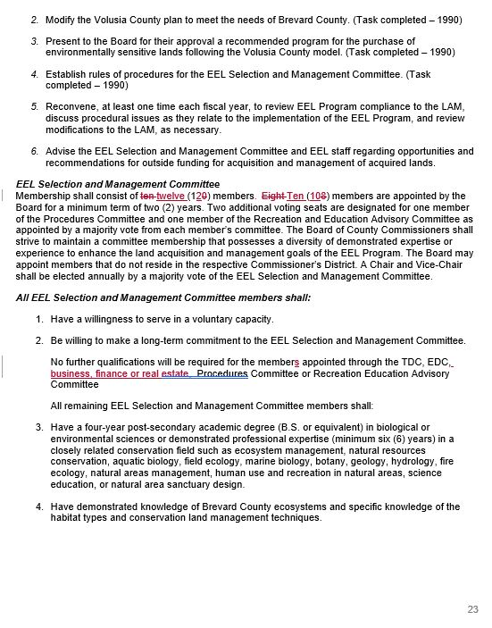

EXHIBIT G
Land Acquisition Manual page 34

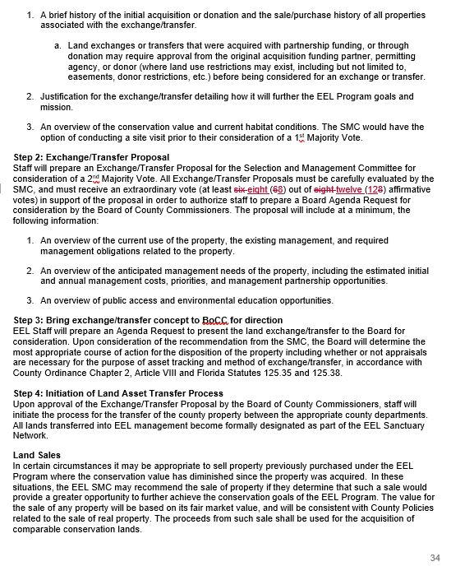

EXHIBIT H
Land Acquisition Manual page 36

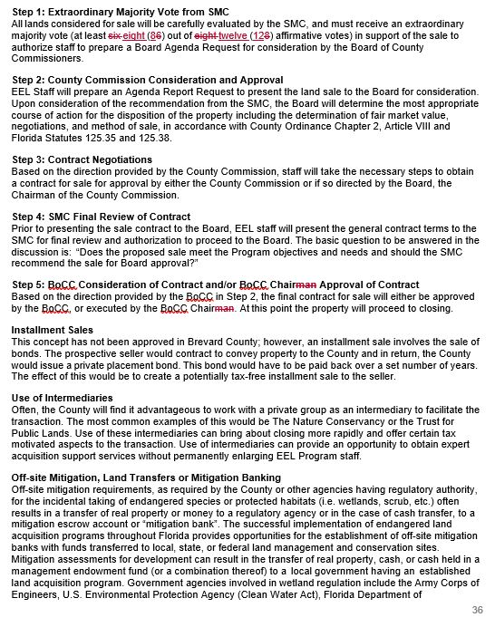

EXHIBIT I
Land Acquisition Manual page 39
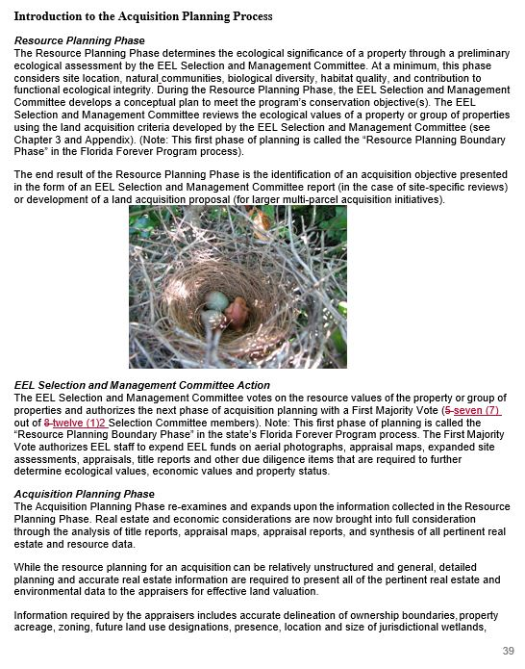

EXHIBIT J
Land Acquisition Manual page 40

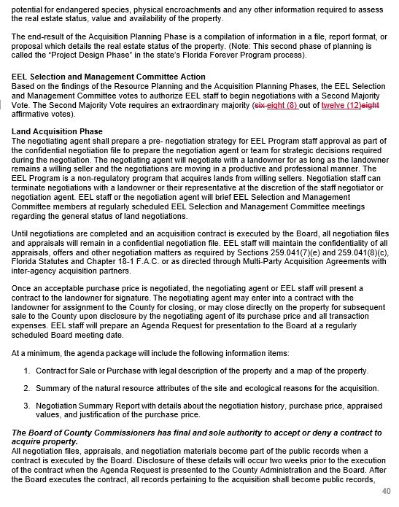

EXHIBIT K
Land Acquisition Manual page 51

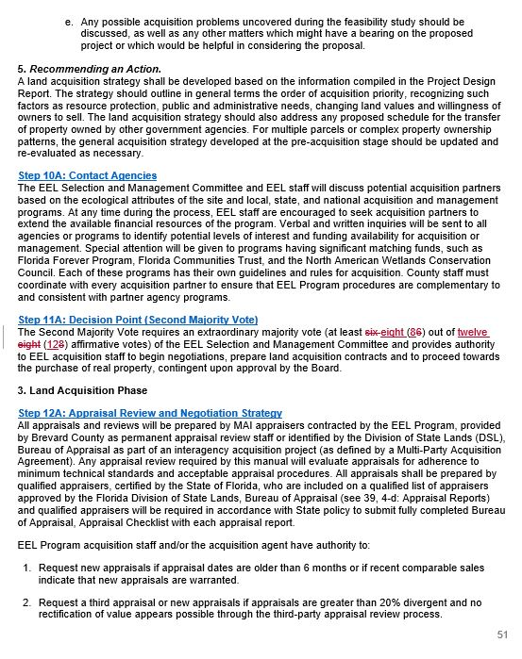

EXHIBIT L
Land Acquisition Manual page 110

