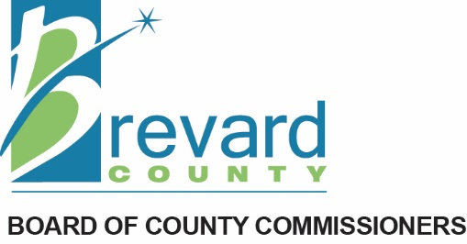

July 22, 2025

Florida Department of Commerce
Division of Community Development
107 East Madison Street
MSC 120
Tallahassee, Florida 32399-6545

Dear Sirs:
Please accept this letter in support of an application from Brevard County for grant funds totaling up to $75,000 from the Florida Department of Commerce, under its Community Planning Technical Assistance program.
From 2011 until earlier this year, local economic development activities and projects in the northern part of Brevard County – home to NASA’s Kennedy Space Center and Cape Canaveral Space Force Station – were largely managed and coordinated by a special dependent district known as the North Brevard Economic Development Zone. Using tax increment funding, the Zone achieved success in helping local businesses expand, redeveloping existing commercial and industrial buildings, attracting new firms, and assisting entrepreneurs with business startups. Borne out of a need to overcome several structural barriers (such as a large amount of federally owned land present in the north end of the county), the Zone used targeted financial assistance to induce job creation and capital investment in the county.
Citing the need to address other financial concerns in the county, the Brevard County Board of County Commissioners (BOCC) dissolved the Zone in May 2025, and reallocated its funding to other county departments. The dissolution of the Zone also meant an end to its economic development strategic plan for north Brevard, which was developed by the Zone and approved by the BOCC in 2012.
In the absence of a plan to continue economic development activities in the north end of the county, the BOCC now desires to undertake a formal strategic planning process to determine the best path forward, post-Zone. It envisions that such a plan would involve:
- Assessing current economic conditions in the north end of the county, along with analyzing economic data;
- Identifying key stakeholders and obtaining comments/feedback regarding economic development needs and realities;
- Conducting an exercise to determine the area’s strengths, weaknesses, threats, and opportunities for development;
- Creating specific goals, along with an action plan for implementing achievable objectives in partnership with other organizations and entities working on economic development activities; and,
- Developing a set of metrics to evaluate economic development efforts and outcomes.
In addition, such a plan would examine the economic and environmental vulnerabilities of the northern end of the county, and identify steps to lessen possible adverse impacts, all with the aim of making the area more economically resilient.
If selected for this Community Planning Technical Assistance grant, Brevard County would engage the services of the East Central Florida Regional Planning Council to develop the economic development strategic plan, based upon tasks outlined in a more detailed scope of work, which will be attached to the formal application for this grant.
Thank you for considering this request. Should you have any questions, please contact Kristin Lortie, Brevard County Commission District 1 Office, at 321-607-6901, or electronically, at D1.Commissioner@Brevardfl.gov.
Sincerely
Rob Feltner

Chairman,
Brevard County Board of County Commissioners

